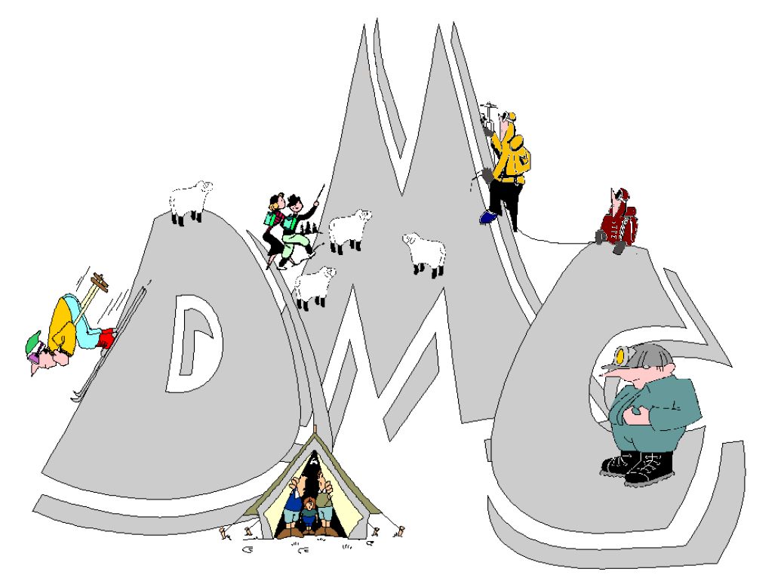

The Derwent Mountaineering Club (DMC) is based in Matlock, Derbyshire and welcomes prospective members. The club is actively involved in all mountain related activities and is affiliated to the British Mountaineering Council (BMC).
Club Website: www.derwent-mountaineering-club.co.uk
Club Secretary: secretary@derwent-mountaineering-club.co.uk

Applications for climbing membership of the DMC will be considered after attending 3 meets within a 3 month period as a prospective member. Prospective members are invited to participate at any of the club meets, being responsible for their own actions and involvement.
After 3 meets, prospective climbing members will be eligible for full membership.
Walking members will be invited to a walking meet prior to joining the club.
Prior to attending your first meet please complete the details below and sign that you have read and understood the following declaration and return to the Club Membership Secretary (either by email or post). Please visit the website or contact the secretary if you require additional information.

Declaration:
I wish to apply for membership of the Derwent Mountaineering Club and will attend three meets within a three month period as a climbing prospective member. After the three month period, I will be eligible for full membership. As a prospective walking member I will attend one walking meet prior to joining the club.
On acceptance of full membership the annual subscription of £28 (renewable the following October), will be presented to the Club Membership Secretary. Cheques should be made payable to ‘Derwent Mountaineering Club’.

I am over 18 and I accept that mountaineering, hill walking and rock climbing are activities with a danger of personal injury or death, and I wish to participate in them voluntarily. I am aware that other members of the club that are perceived to be ‘in charge’, or even just leading a walk, are not necessarily qualified, do not need to be qualified, are not regarded by the club nor regard themselves as ‘technical experts’,

but are amateur climbers, walkers or mountaineers with some experience who are happy to impart their knowledge and that any advice given be viewed with this in mind by the recipient.

If accepted as a full member I agree to abide by the constitution of the club.
Data Protection Act 2018
In order to provide our services to you we need to collect and retain some of your personal information. Some of this information is provided explicitly by you and other information may be collected by us through interaction with the services we provide. The information we hold about you includes:

- Your contact details name, address, email address and telephone numbers)
- Date of birth
- Photographs taken by other club members
- Information obtained via the website e.g. your IP address.

With your consent we share your contact details with other members and with the British Mountaineering Council.
I consent to the personal information I have given you being held on file by the DMC, and to have my address, telephone number and email address being circulated to the DMC members, BMC (and date of birth of BMC only) and used for the purposes of the DMC.
Photographs of you taken by other members during club activities may be placed on our website.
I consent to photographs of me with my name being placed on the website.
Please see the Privacy Notice on our website for more detailed information.
You can ask us to delete the data we hold about you but this may prevent us from providing the services of the club to you.
You can ask us to delete the data we hold about you but this may prevent us from providing the services of the club to you.

Name ………………………………………………………………………………………………………………
Date of birth ………………………………………………………………………………………………………
Address ……………………………………………………………………………………………………………

Tel No (H) ………………………………………… (M) ………………………………………………………...

E-mail ………………………………………………………………………………………………….…………..

If you are a prospective climbing member please give a brief outline of your climbing experience and the level you climb at.

How did you hear of the club?

Signature ……………………………………………………………… Date ……………………………….…

